CHE517 ADVANCED PROCESS CONTROL
FINAL EXAM
Professor Shi-Shang Jang Jan. 11, 2010

Problem #1 (25%)

For the stripping section of a distillation column shown below, the objective is to maintain the bottom’s purity at a desired value. The objective is commonly attained by controlling the temperature in one of the trays (the column pressure is assumed constant) by using the steam flow to the reboiler as the manipulated variable. A usual “major” disturbance is the feed flow to the column.
- Sketch a feedforward/feedback control scheme to compensate for this disturbance; describe it briefly.
- Briefly describe the dynamic tests that you would perform on the column in order to tune the feedback controller and the feedforward controller. Would you expect the dynamic compensation on the feedforward controller to be a net lead or a net lag?
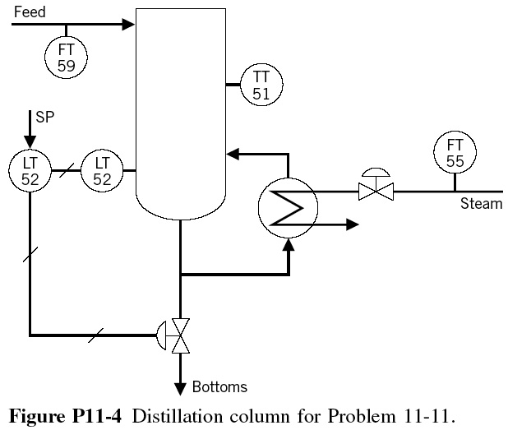

Problem #2 (25%)
Consider the following multivariable plant
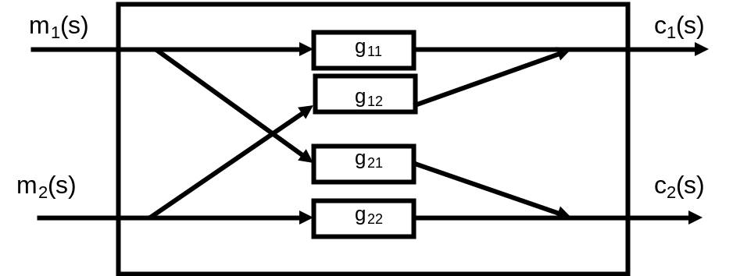
- Design a decoupler:
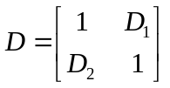

find the analytical solution for D.
- Consider the following matrix
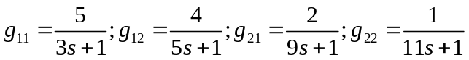
Calculate the relative gain for the system, is there a good pairing strategy for the 2×2 system?

Problem #3 (25%)

Consider the following Internal Model Control Structure (or Model Predictive Control Structure:
G_{I}
G_{m}
G_{P}
y_{s}
e
d
y
y_{m}
u
+
+
+
-
-
+

Show that:

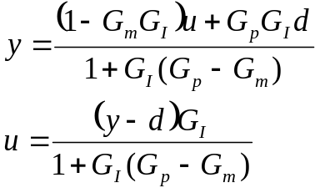

Based on the above derivation, also show that:
- Dual stability: y and u are both stable provided that G_{p}=G_{m}, G_{p} and G_{I} are stable.
- Perfect Control: y=y_{s} provided that G_{p}=G_{m}, G_{p}=G_{I}⁻¹ and G_{I} realizable.
- Zero offset: y(0)=y_{s}(0) provided that G_{m}(0)=G_{I}⁻¹(0).

Problem #4 (25%) – Take home

(i) Construct a pulse response model for the following process:
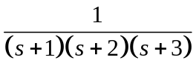
with H=10.
(ii) Demonstrate the predicting capability using a random number input to the process and model simultaneously.
(iii) Design a MPC controller and show that the controller works with P=4, B=4.
(iv) Show that MPC controller and show that the controller works with P=4, B=2.

